a) | Differentiate:
 | (i) 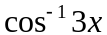 | 1
 | (ii) 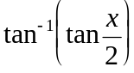 | 2
b) | Solve the equation: for . | 4
c) | Find 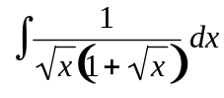 using the substitution 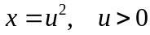. | 2
d) | Evaluate 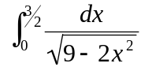 | 3
QUESTION 1 (Start a new Page)

QUESTION 2 (Start a new Page)

a) | For the function 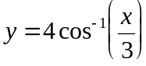  (i) find the domain and range. | 2
 | (ii) sketch a graph of the function. | 2
 | (iii) find the area of the region in the first quadrant bounded by the curve and the co-ordinate axes. | 2
b) | The chord of contact of the tangent to the parabola 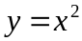 from the point 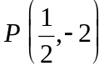 passes through the parabola at M and N.
 | (i) show that the equation of the chord of contact is 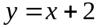. | 2
 | (ii) find the coordinates of the points M and N. | 2
 | (iii) find the area bounded by the parabola and the chord of contact. | 2

QUESTION 3 (Start a new Page)

a) | If 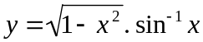
 | (i) find 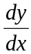. | 2
 | (ii) express 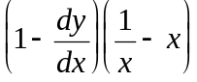 in terms of y. | 3
b) | Evaluate 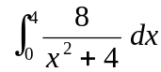
 | (i) exactly. | 2
 | (ii) using Simpson’s Rule with 5 function values (give answer to 3 decimal places). | 2
c) | Solve for θ : 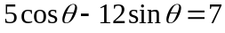, giving answers to 2 decimal places. | 3

QUESTION 4 (Start a new Page)

a) | (i) Write in terms of . | 1
 | (ii) Hence, find 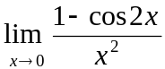. | 2
b) | The volume flow rate of water through a pipe is given by 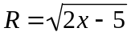 litres per second. If there is initially no water in the pipe, find the exact volume of water after 2 minutes. | 2
c) | The figure shows a sketch of the curve  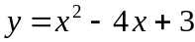.  Figure not  to scale.  (i) Find the largest positive domain such that  the graph defines a function 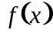 which has an inverse. | 2
 | (ii) Find the inverse function and state its domain. | 3
 | (iii) Sketch the graph of the inverse function 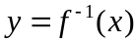. | 2

QUESTION 5 (Start a new Page)

a) | In the diagram above, 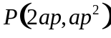 is a point on the parabola 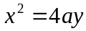 with focus 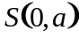. The point Q lies on PS produced, and Q divides PS externally so that  PQ:QS = −3:2.  (i) Prove that Q has co-ordinates 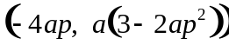. | 1
 | (ii) Show that as P varies the locus of Q is another parabola. Find its equation. | 2
 | (iii) Also, find the co-ordinates of its vertex and its focus in terms of a. | 2
b)
 | In the diagram, PS and QR are tangents to the circles with centres A and B. The tangents intersect at X and A, X and B are collinear.
 | (i) Show Δ APX ||| Δ BSX, giving reasons. | 2
 | (ii) Suppose the diagram represents two wheels of radius 5cm and 3cm that are placed with their centres 16cm apart. A taut string surrounds the circles and crosses itself between them.  Find the exact length of the string. | 5

QUESTION 6 (Start a new Page)

a) | Find the exact volume of the solid formed when the region bounded by the x-axis and the curve 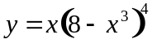 between x=0 and x=2 is rotated about the x-axis. (You may need to use the substitution 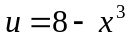 to evaluate the integral involved). | 3
b)
The illumination I at a point P on the edge of a circular table of radius r metres is given by: 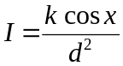,
where k is a constant, d is the distance from the light to the edge of the table and
x is the angle as shown in the diagram. The light is directly above the centre 0 of the table.
 | (i) Show 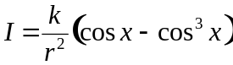 | 3
 | (ii) Hence or otherwise, show that the light should be placed at a height of 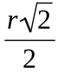 metres above the table in order to give the strongest illumination at P. | 6

